**BAHRIA UNIVERSITY,**

**(Karachi Campus)**

*Department of Software Engineering*

**Assignment#02– Fall 2021**

**COMPLEX ENGINEERING PROBLEM**

COURSE TITLE: **SRE**  COURSE CODE: **SEN-211**

Class:  **BSE 3B** Shift: **Morning**

Course Instructor: **ENGR. BUSHRA FAZAL KHAN** Assignment Date: **22-Nov-2021**

Max. Marks: **4 Points: CLO 5** Assignment Due: **14-Dec-2021**

**GROUP MEMBERS:**

**M Muaz Shahzad 02-131202-081**

**Shahab Tahir 02-131202-011**

**Talha Zafar 02-131202-080**

**Awais Asad 02-131192-062**

_____________________________________________________________________________

Question 1) As part of your Software Requirement Engineering Course your team must work on a client-based project. For the groups assigned in the class identify a client and create a Scope

Vision Document. Be sure to cover the following contents in your document

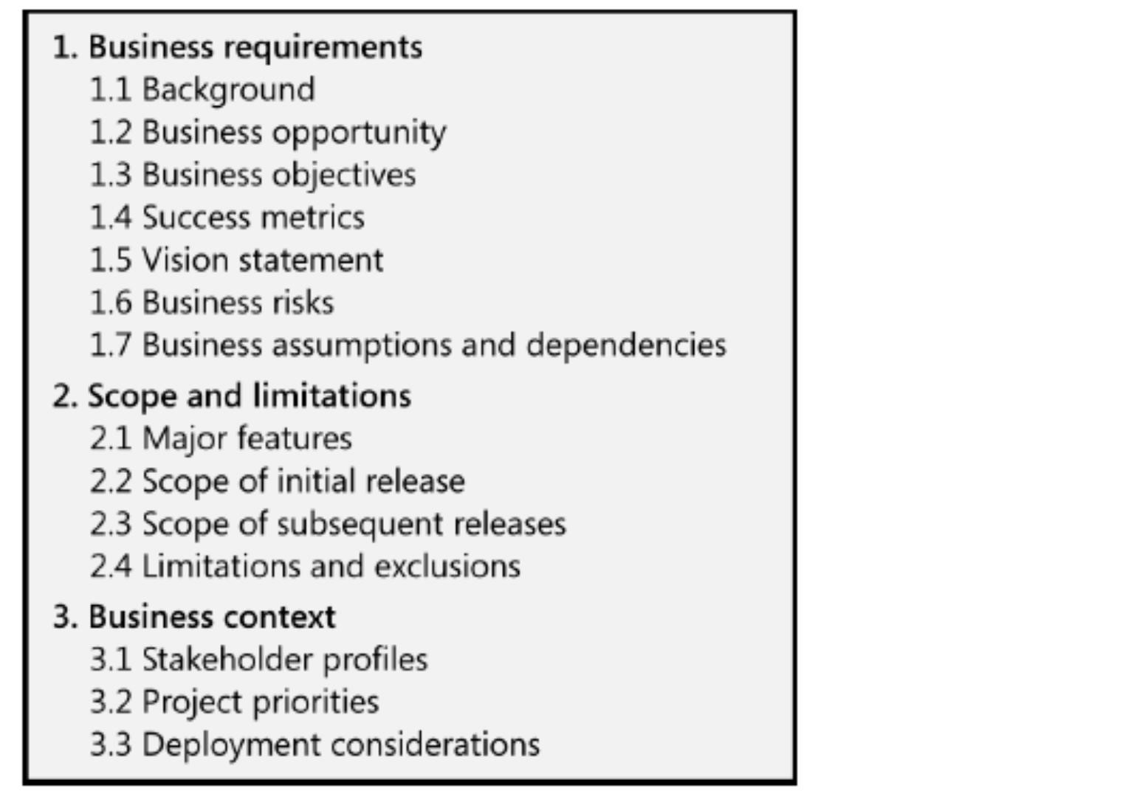

**1.BUSINESS OPPORTUNITY:**

* 1. **BACKGROUND:**

Restaurants are a place to relax. During weekends, it gets very crowded. Moreover, the manual system results in long hours of waiting and inconvenience. Workers have load burden and have short time to manage orders, we feel there is a need for an automatic system which makes it convenient for customers to dine inn and relax, pre-order and takeaway.

**Manual Take away:** if a customer wants something for takeaway, he must wait unless the order is prepared.

**1.2. BUSINESS OPPORTUNITY:**

The goal for developing this app is to create convenience for customers and save their time by utilizing the “pre-order” option. Moreover, there are many other options which makes ordering and food selection feasible for the customers. Budget is an important factor for people while looking up for food options, hence the app provides “budget (low to high/high to low)” wise allocation of deals making it convenient for people to order within their desired budget.

**1.3. BUSINESS OBJECTIVES:**

* Budget (low to high/high to low) wise allocation of deals
* Reduce long waiting time for takeaway at 2 – 2.5 months following initial release.
* Increase work speed by average 5 minutes per order

**1.4. SUCCESS CRITERIA:**

* On the scale of 1-5, the customer satisfaction rate calculated should be no less than 70% within after 3 months of release.
* Have 70% positive reviews within 2 months after launch
* Receive no more than 30 report issues on app, 8% bad reviews within 1 month after launch

**1.5. VISION STATEMENT:**

**FOR** customers **WHO** visits restaurant or need to order food conveniently saving their time and avoiding long queue. **THE** “Restaurant Management App” The app will have the ability to order via mobile phone by scanning a QR code placed at each table and allows customers to dine inn and relax. Moreover, the app will also have a feature for takeaway which will benefit the customers who do not have time to visit the food court. The app will allow them

to order online, track their order and collect on receiving a confirmation message. Users can also get their food delivered to their homes. **Unlike** the current manual ordering process, **OUR PRODUCT** will automate the process and analyse and record customers reviews for better visibility.

**1.6. BUISNESS RISKS**

* Too few customers might use the application and adaptability rate might be low, reducing return on investment
* The app might not result in providing a user-friendly interface to the customers

**1.7. ASSUMPTIONS AND DEPENDENCIES:**

* Internet-enabled computers will be available in the food court at each food stall
* Customer will be required smartphones and internet access to order
* Workers of restaurant should be aware with such technology
* The memory usage of the app will have to be constrained by the devices it is intended to run. Since most tablets, Android phones may have limited memory.

**2.SCOPE AND LIMITATIONS:**

**2.1. MAJOR FEATURE:**

**CUSTOMERS:**

* Scan QR Code to get list of food
* Browse through different menus and deals along rates.
* Customize the list according to the following criteria:
* All
* Food category
* Budget
* Deals/ Discounts
* Ratings

**WAITER:**

* Pending orders

**CHEF:**

* Get notification of new order
* View orders by their order time

**ADMIN:**

* Add new feature
* Manage accounts
* Track monthly report

**ASSUMPTIONS AND DEPENDENCIES:**

* Customer will be required internet access to order
* The memory usage of the app will have to be constrained by the devices it is intended to run. Since most tablets, Android phones may have limited memory.

**2.2. SCOPE OF INITIAL RELEASE:**

|  |  |  |
| --- | --- | --- |
| **Feature** | **Release 1** | **Release 2** |
| **1** | Customers can Scan QR Code to get list of food. |  |
| **2** | Customers can browse through different menus and deals along rates. |  |
| **3** | The app will customize the list according to the following criteria:   * All * Food category * Budget * Deals/ Discounts * Discount on Cards * Ratings |  |
| **4** | Place Your Order for Dine inn |  |
| **5** | Place Your Order for Takeaway (Collect/Get it delivered) |  |
| **6** | Online Payment via credit card |  |
| **7** | Helpline/Call for Complain |  |
| **8** | Report a Problem |  |
| **9** | Admin can Add new feature |  |
| **10** | Admin can Manage accounts |  |

**2.2. LIMITATION AND EXCLUSIONS:**

* This scope is limited to only application.
* No websites will be provided with that

**3.BUISNESS CONTEXT:**

**3.1. STAKEHOLDER PROFILES:**

**CUSTOMER:**

* Convenience and feasibility; time saving
* Not use as probably use to old manual system
* Avoid the hassle of long queues, Simplicity of use, categorization of food
* Access to internet is required.

**WAITER:**

* Less work burden & time saving.
* Must have awareness of such system before.
* Should exactly know what order to deliver.
* New commerce might face difficulty using such system.

**CHEF:**

* Less confusion about orders.
* Must have awareness of such system before.
* Customer should be happy.
* Desktop devices with internet access is required.

**ADMIN:**

* Improved employee productivity
* Daily/Monthly reports might help him improve customer’s experience.
* Customer should be happy.
* Desktop devices with internet access is required.

**3.2. PROJECT PRIORITIES:**

|  |  |  |  |
| --- | --- | --- | --- |
| **Dimension** | **Driver** | **Constraint** | **Degree of Freedom** |
| **Schedule** |  |  | Overrun of up to 4 weeks acceptable |
| **Features** |  | All features scheduled for release must be fully operational and able to handle any errors that occur |  |
| **Quality** |  | 90% of tests should follow security standards must be demonstrated |  |
| **Staff** | Developer is required (one for staff and one for customers). Q/A team should be available for testing. Project  Manager is required to manage the entire project. |  |  |
| **Cost** |  |  | Budget overrun up to 10% is acceptable |

**3.3. DEPLOYMENT CONSIDERATION:**

* High speed internet should be available in restaurant premises.
* Servers should be compatible with the app and should handle load
* Apps must be developed for android, IOS and another mobile operating system